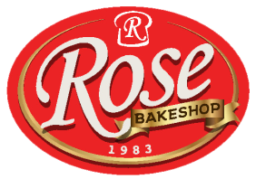
JATHNIER CORPORATION
RUBY ST., RGA VILLAGE, DACUDAO,
DAVAO CITY, PHILIPPINES.
(082) 282 2439
M E M O R A N D U M
WMD.MEMO-2023-10-009
October 5, 2023

TO: EMD & OPERATION
Cc: DLC, MGC, LOGISTIC, HR Department-Jathnier and Rose Food Realty
FR: PROPERTY COSTUDIAN DEPARTMENT
Subject: REITERATION OF RETURN/PULL OUT POLICY
This is to reiterate the existing policy for return/pull out of items from branch to EMD. These are materials and equipment that the property custodian for oversees. Our current policy states that "ALL ITEMS RETURNED/PULLED OUT BY BRANCH, MUST BE ENDORSED FIRST TO PROPERTY, TO PHYSICALLY CHECK BOTH ITEMS AND DOCUMENTATION, BEFORE TURNING OVER TO EMD SHOP FOR THE NECESSARY REPAIRS WITH DOCUMENTATION PROVIDED BY THE PROPERTY," but this was not consistently adhered to.
In order to follow and observe this policy, we encourage everyone to give your full commitment and support because this policy is a shared responsibility that everyone is obliged to follow.

Thank you

Prepared by: Reviewed by: Reviewed by:

Kristine C. Munda Meraflor L. Cariquitan Gabriel L. Cuaycong
Asst. of the VP Finance Head/ General Manager

Approved by:

MELINA G. COMEDIDO
VP OPERATIONS DIRECTOR

DANTE L. COMEDIDO
PRESIDENT

